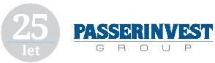

**PRESS RELEASE** Prague, 23rd May 2017

**PASSERINVEST GROUP is the most admired company in the area of real estate, business services in CZECH TOP 100**

**PASSERINVEST GROUP, the leading Czech development and investment company, came in first in the rankings of the top 100 Most Admired Companies in the Czech Republic in 2017 for activities in the area of real estate, business services, which the CZECH TOP 100 Association organises and announces each year. In addition to this successful placing, it also moved up one spot this year to 8th place in the overall rankings of the 100 Most Admired Companies in the Czech Republic in 2017.**

By receiving the award, PASSERINVEST GROUP, a Czech development and investment company, which is mainly famous in the Czech capital city thanks to building the BB Centrum multifunctional complex and in the Moravian-Silesian Region for its Nová Karolina Park, confirmed that it truly ranks among the top companies in its field. This was also demonstrated by Radim Passer recently receiving the Lifetime Achievement in Real Estate award from the Central & Eastern European Real Estate Quality Awards (CEEQA), which is given to personalities for their significant contribution to the real estate sector in the “new” Europe.

The order of the CZECH TOP 100 rankings is prepared on the basis of the evaluations by managers of significant companies, economic and financial analysts, and representatives of union organisations and professional associations, which this year numbered more than 1500.

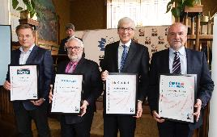

Second from the left: Vladimír Klouda, the Executive Director of PASSERINVEST GROUP, accepts the award

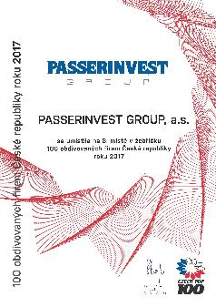

PASSERINVEST GROUP’s diploma

For more information and photographs in print quality please contact:

Kristýna Samková**,** Head of PR and Marketing dept.

**PASSERINVEST GROUP, a.s.**

Tel.: (+420) 221 582 111

Mobil: (+420) 602 186 708

E-mail: [Kristyna.Samkova@Passerinvest.cz](mailto:Kristyna.Samkova@Passerinvest.cz)

www.passerinvest.cz, [www.bbcentrum.cz](http://www.bbcentrum.cz)

Marcela Štefcová

**Crest Communications a.s.**

Mobil: (+420) 731 613 669

E-mail: marcela.stefcova@crestcom.cz

**About the Developer**

**PASSERINVEST GROUP, a.s.,** founded in 1991 by Radim Passer, is a purely Czech development and investment company whose name is associated in particular with the **BB Centrum** multifunctional complex in Prague 4 - Michle. With this project, the most successful and extensive Czech project of its type, the company has built its excellent reputation both at home and at the international level. Contributing to this is not only the high quality of the projects completed to date, but also its high level of service, its sense of fair play, its positive relationship with the tenants and users of its buildings, and its sense of responsibility towards society and the environment. **PASSERINVEST GROUP**’sportfolioincludes other interesting development projects.